signInAuthenticationFailed1659013534748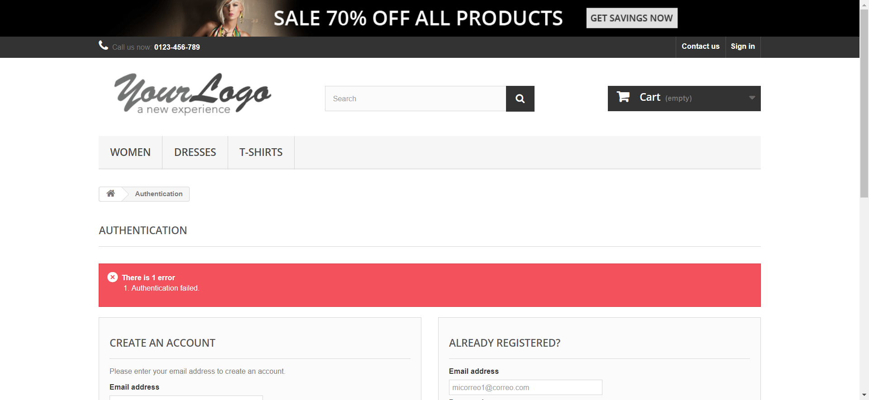

signInEmailInvalido1659013545841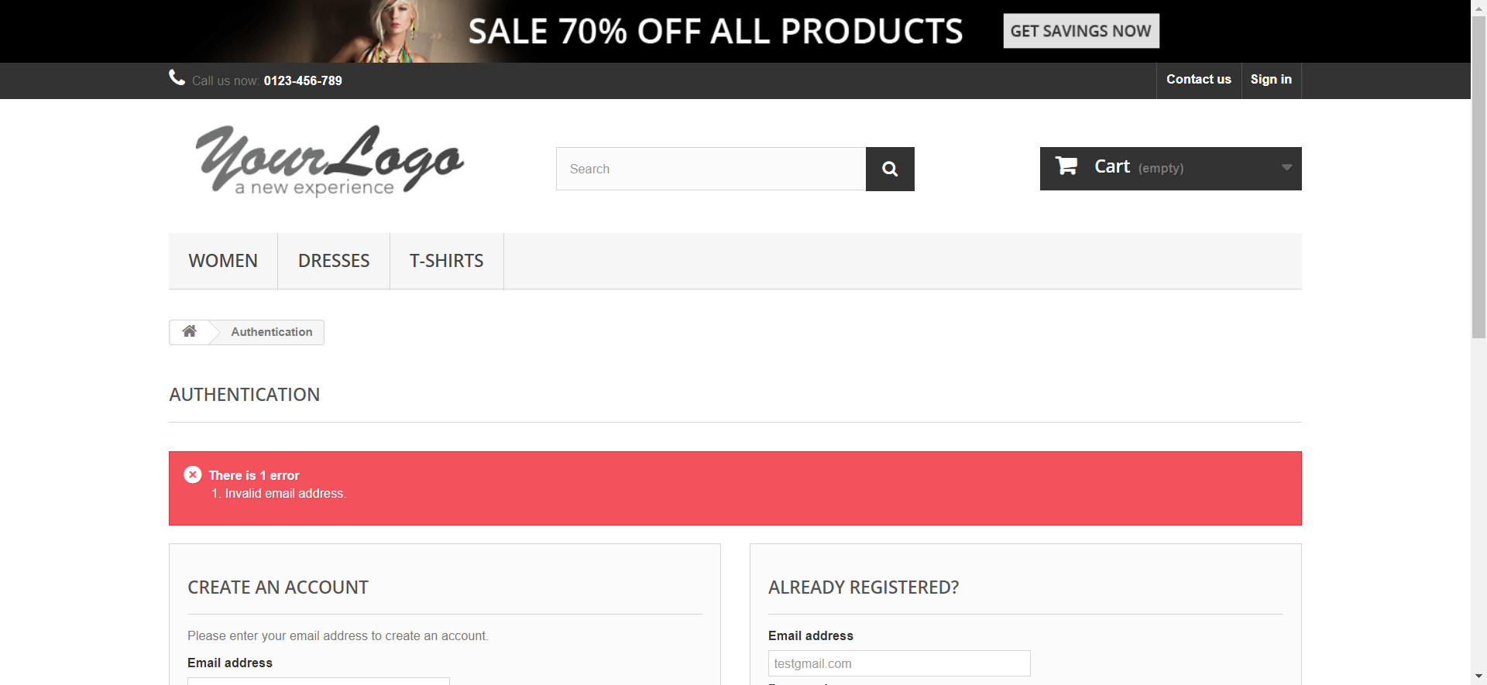

signInEmailInvalido1659013556122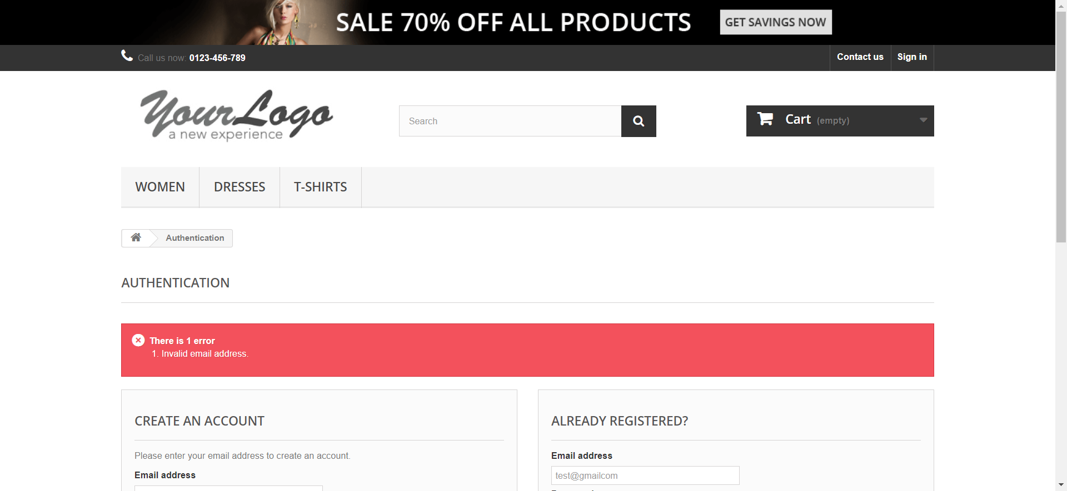

signInEmailInvalido1659013564309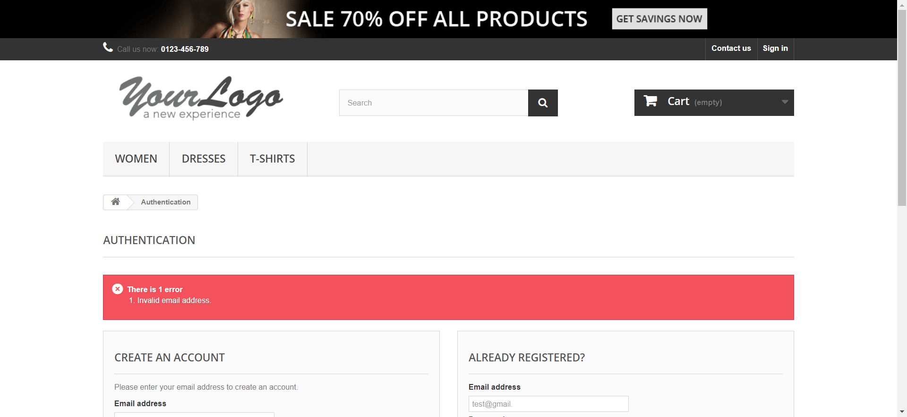

signInInvalidPassword1659013573600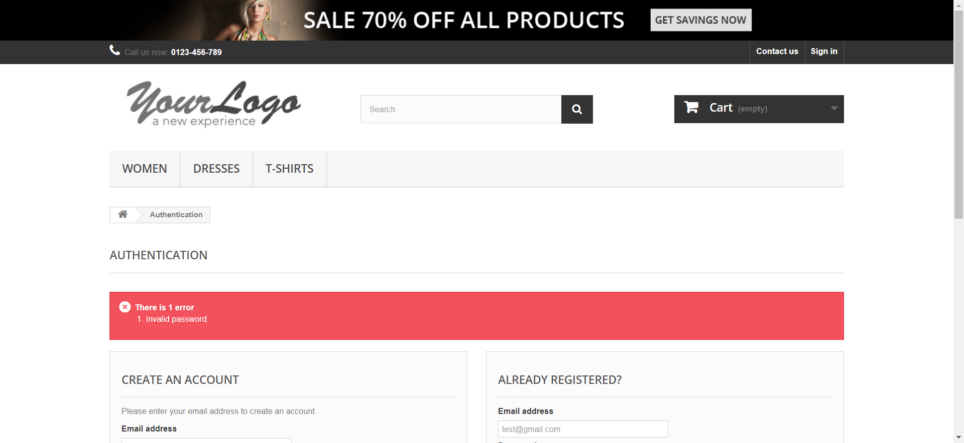

signInInvalidPassword1659013582731

signInInvalidPassword1659013588330

signInRequiredEmail1659013595528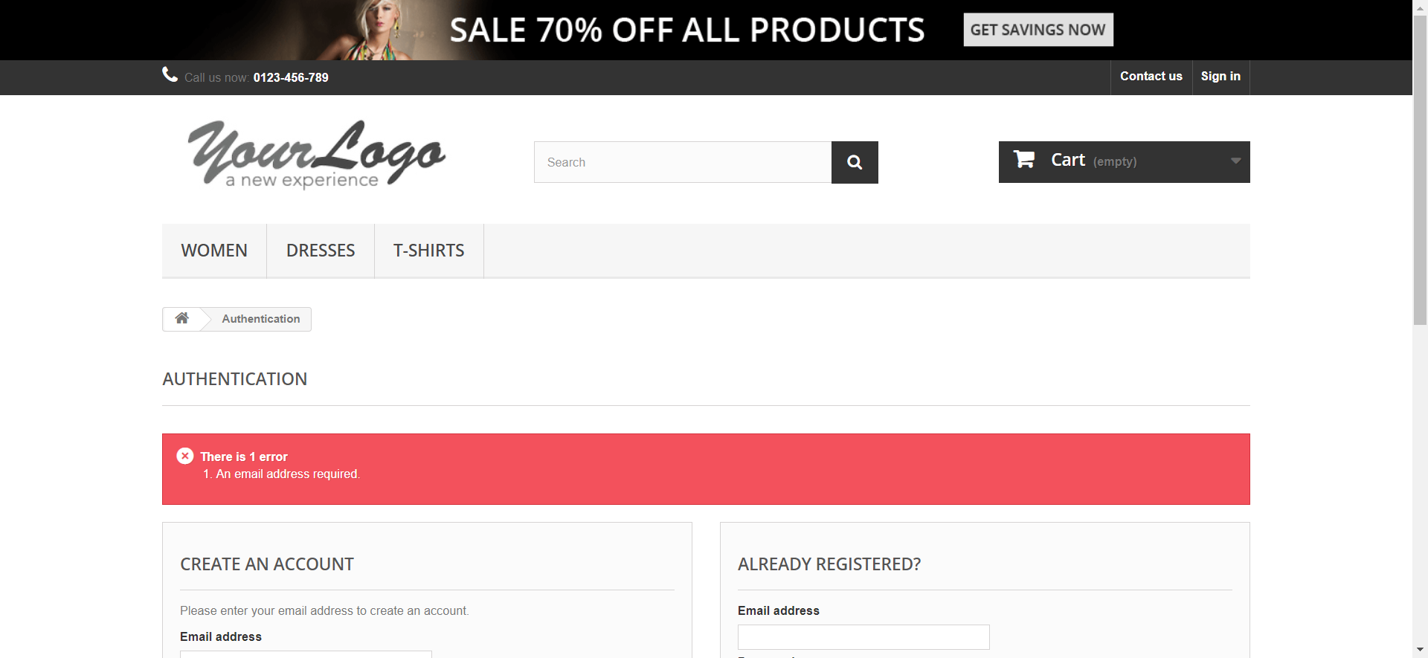

signInRequiredEmail1659013600952

signInRequiredEmail1659013606168

signInRequiredPassword1659013612620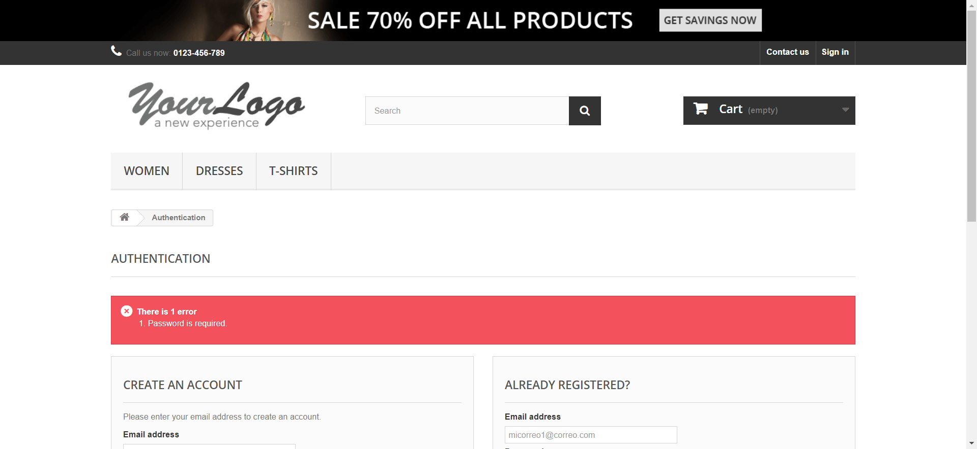

validSignIn1659013618140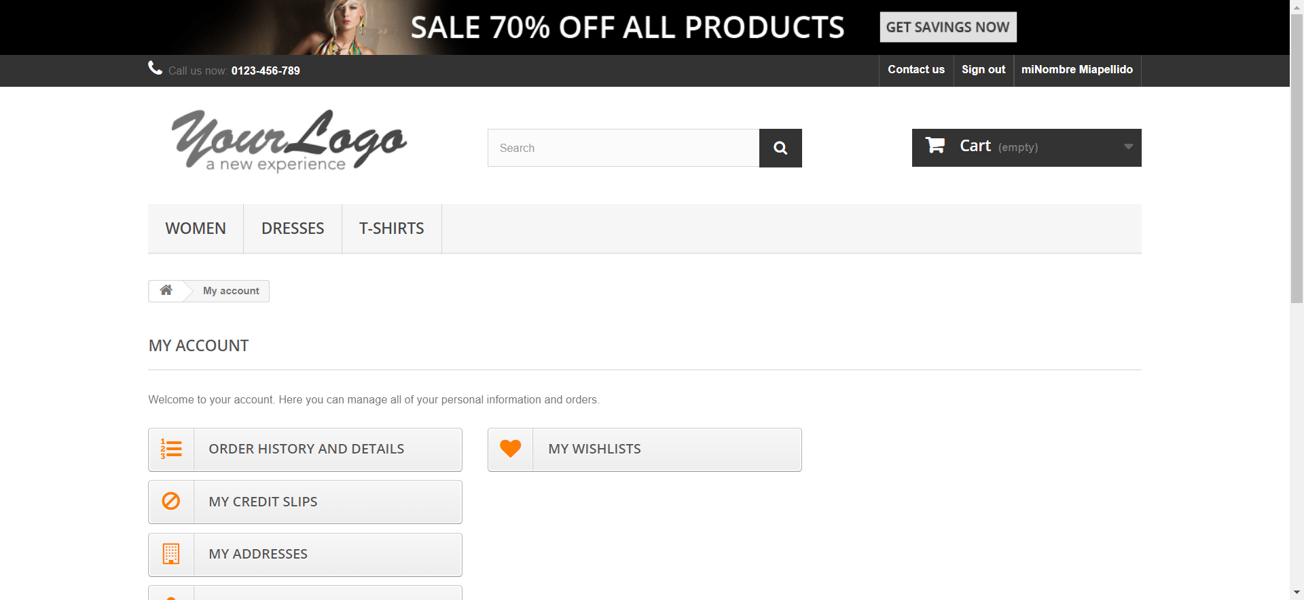

signInAuthenticationFailed1659013652336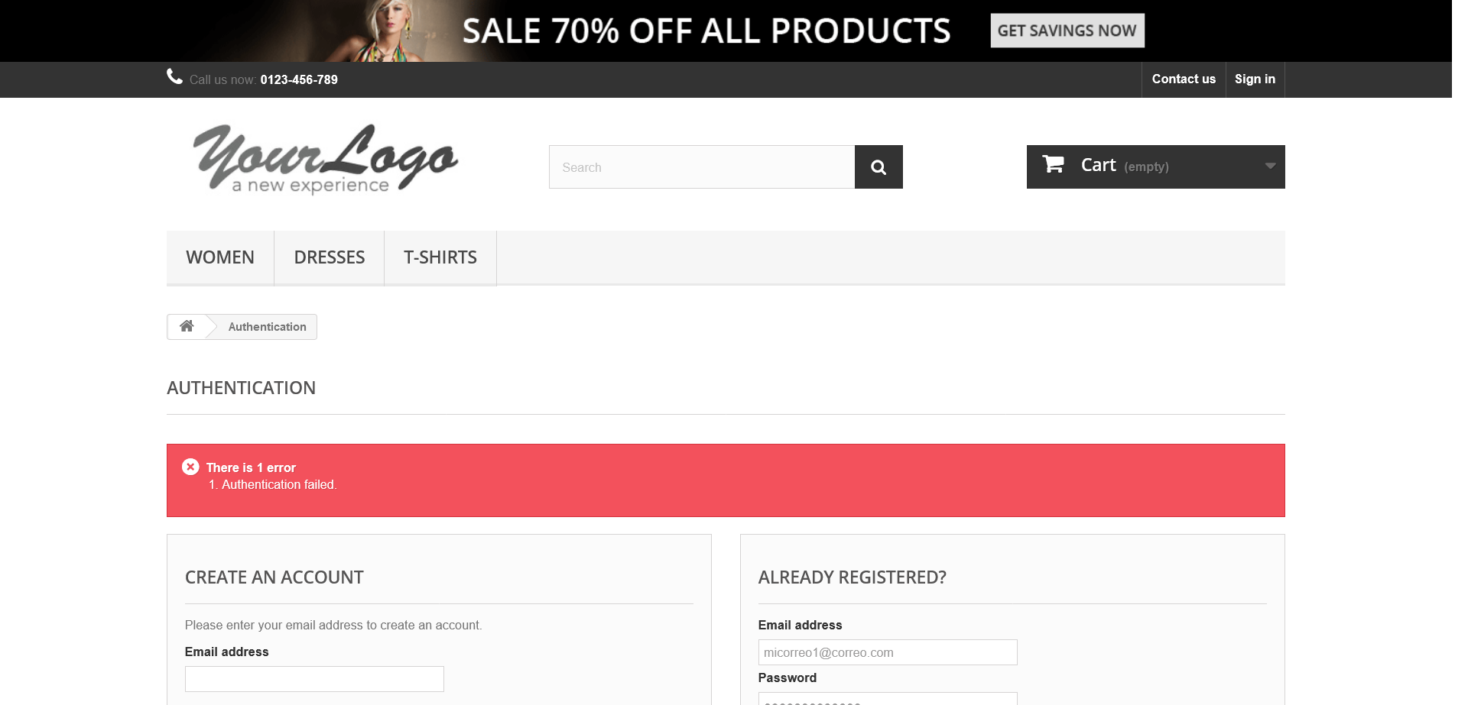

signInEmailInvalido1659013659953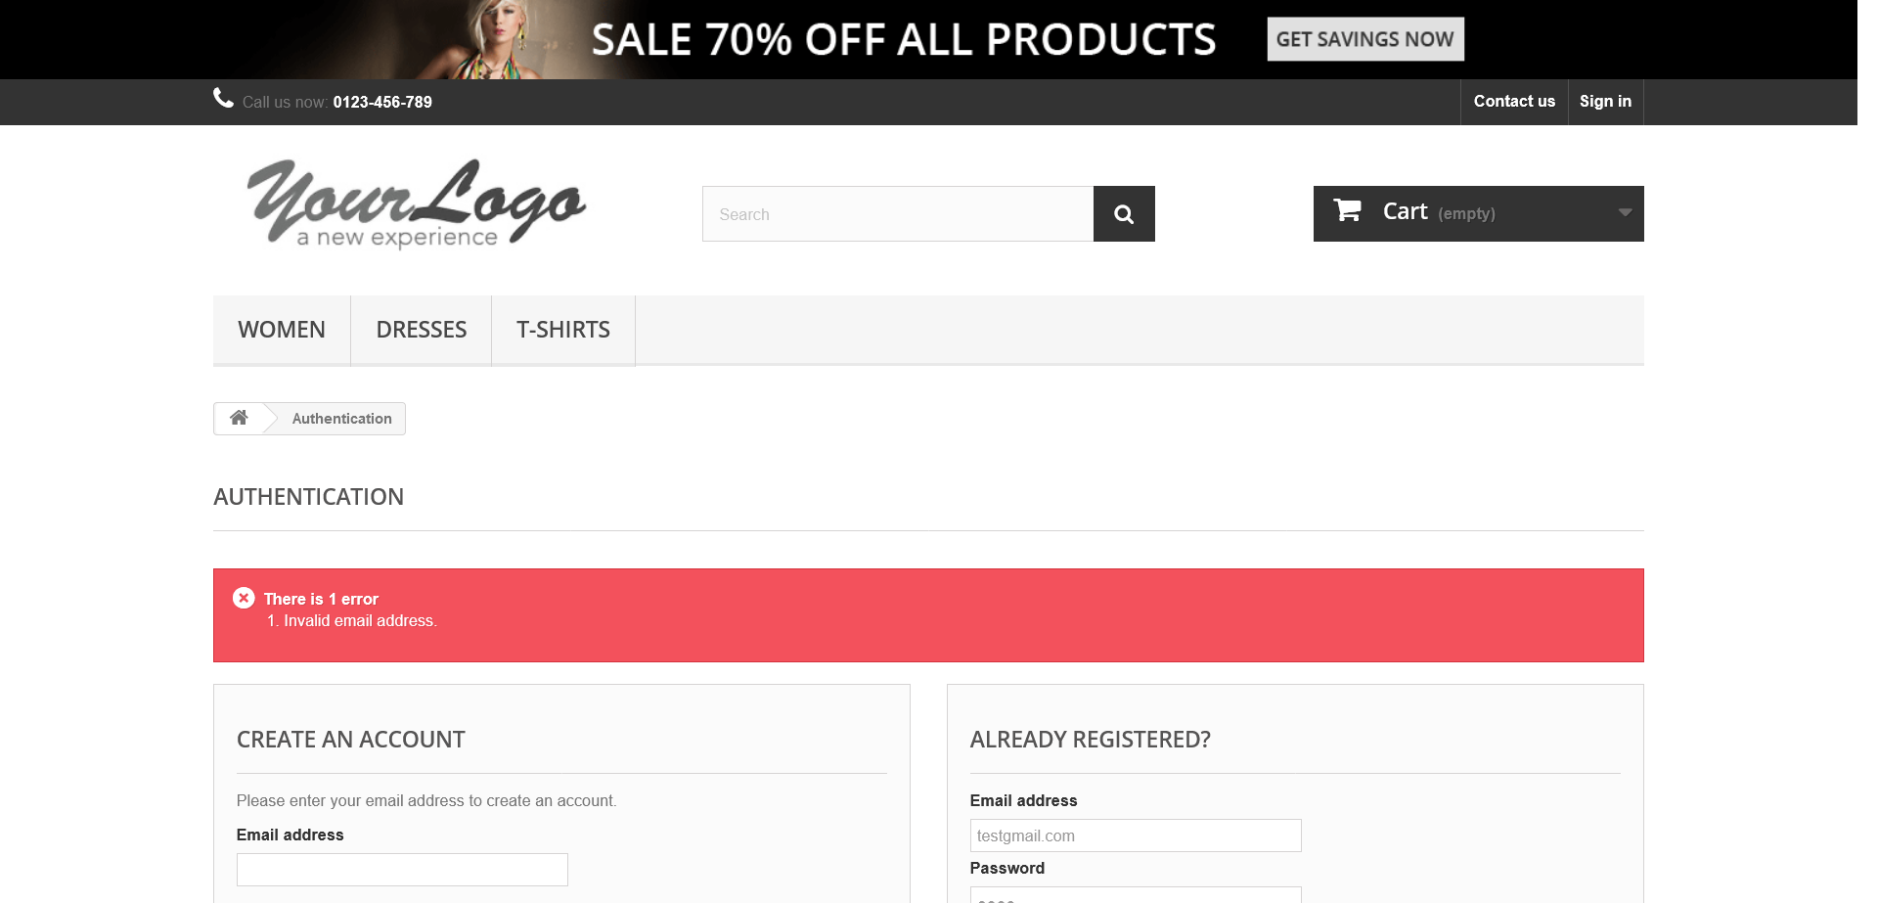

signInEmailInvalido1659013665932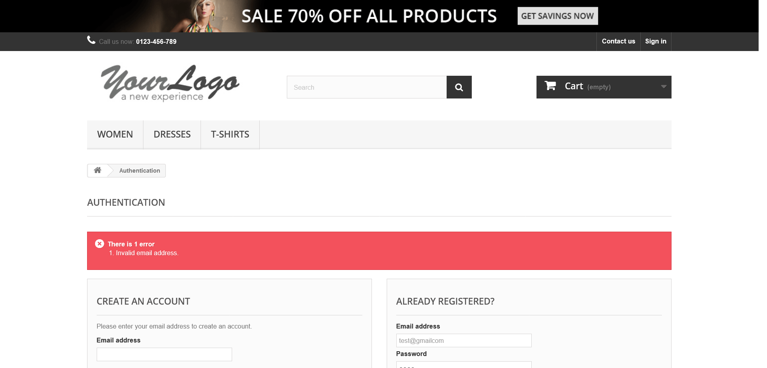

signInEmailInvalido1659013672551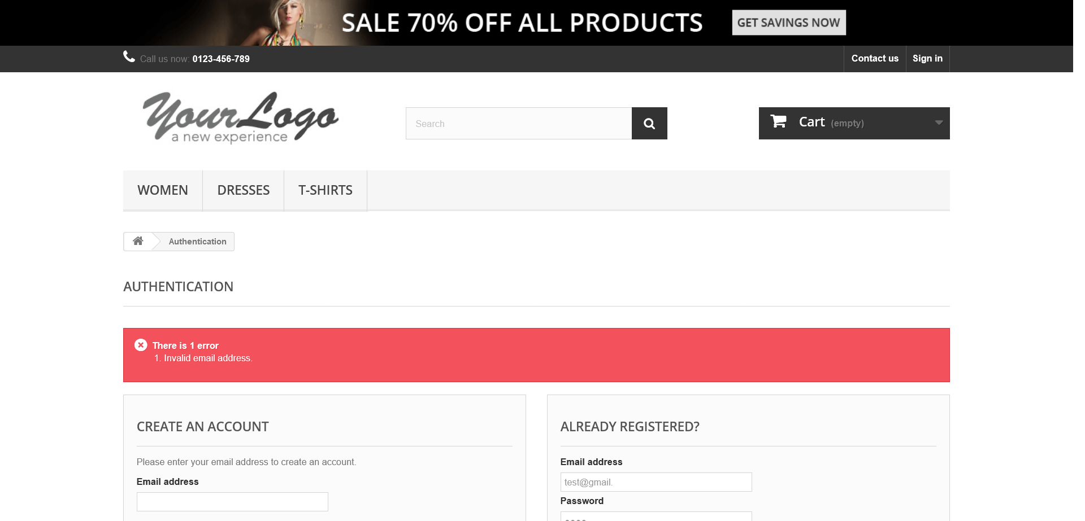

signInInvalidPassword1659013677471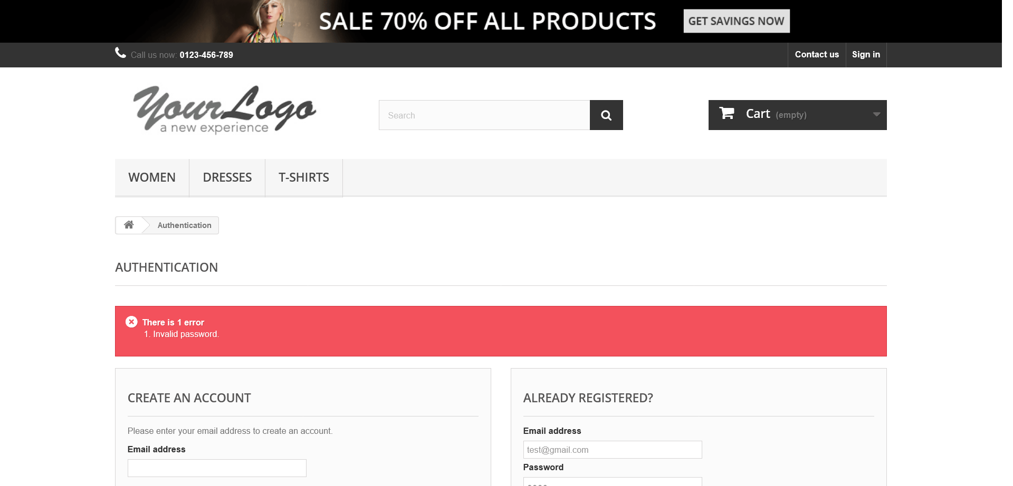

signInInvalidPassword1659013681056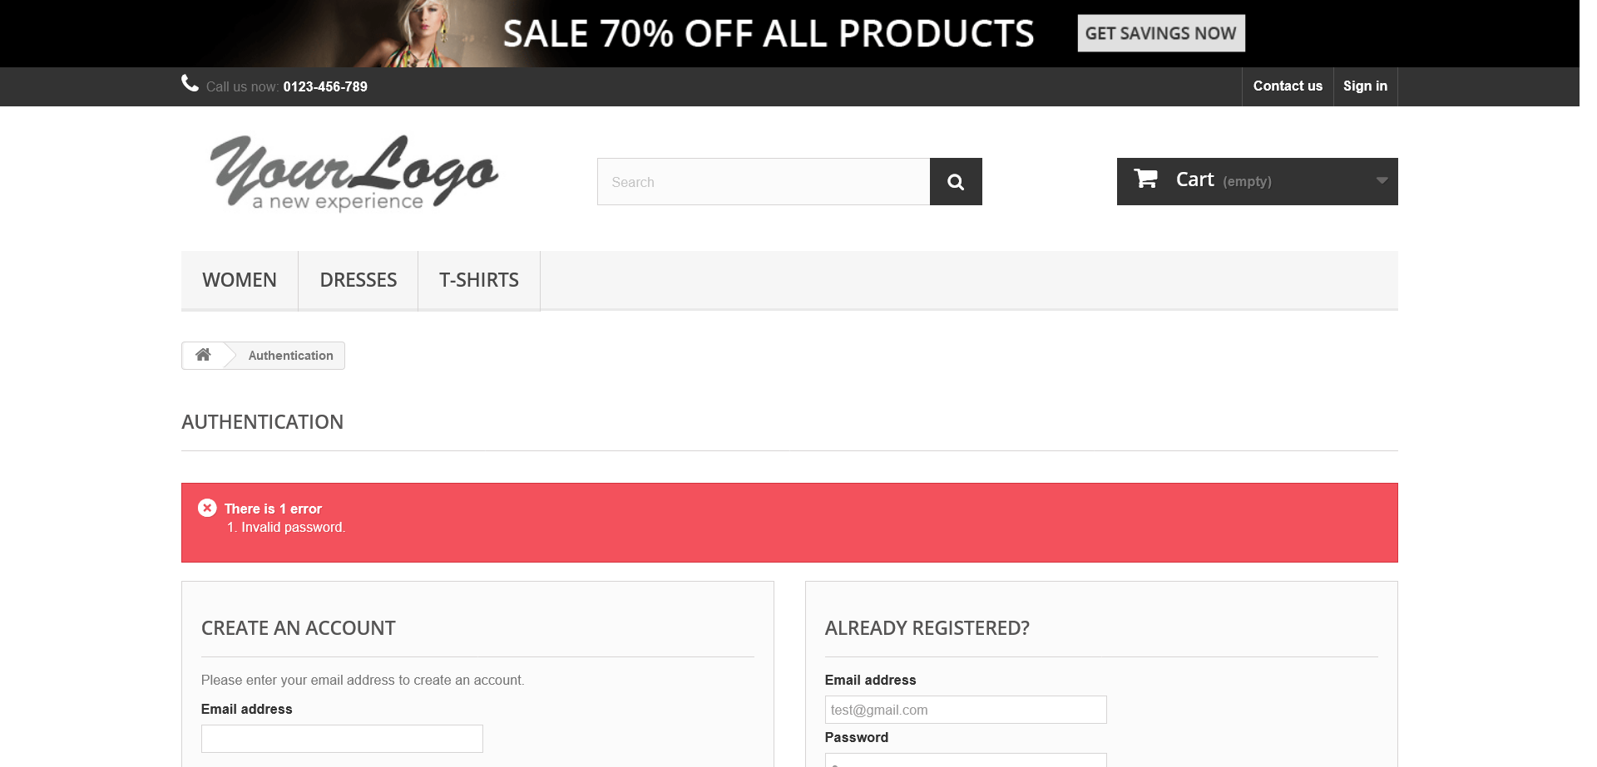

signInInvalidPassword1659013686293

signInRequiredEmail1659013694526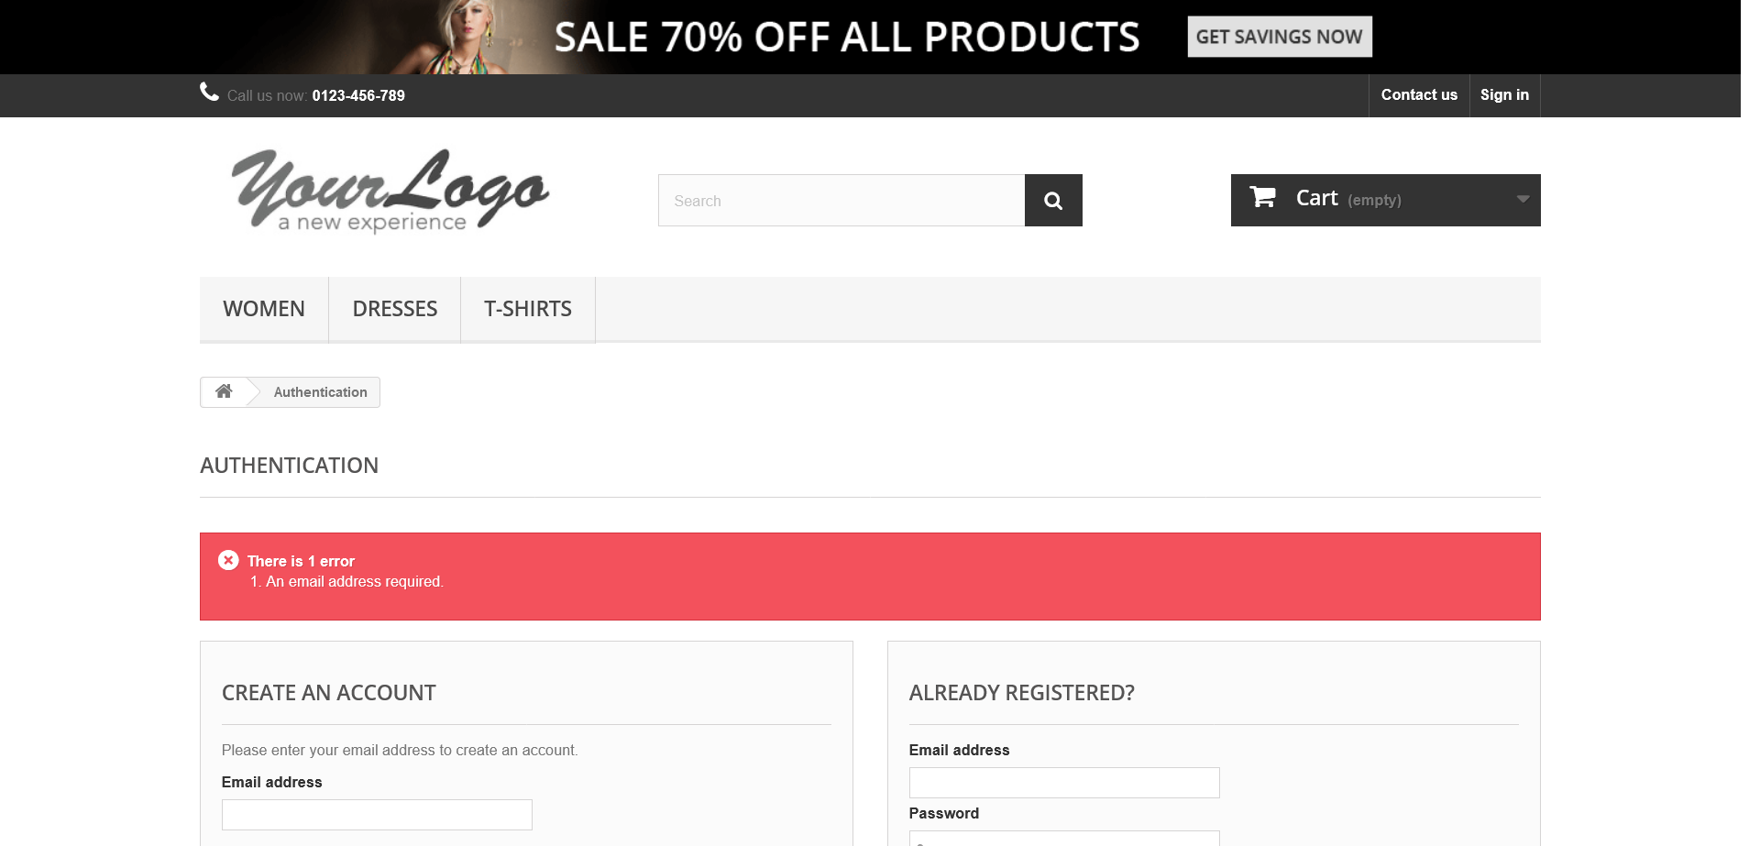

signInRequiredEmail1659013713071

signInRequiredEmail1659013725943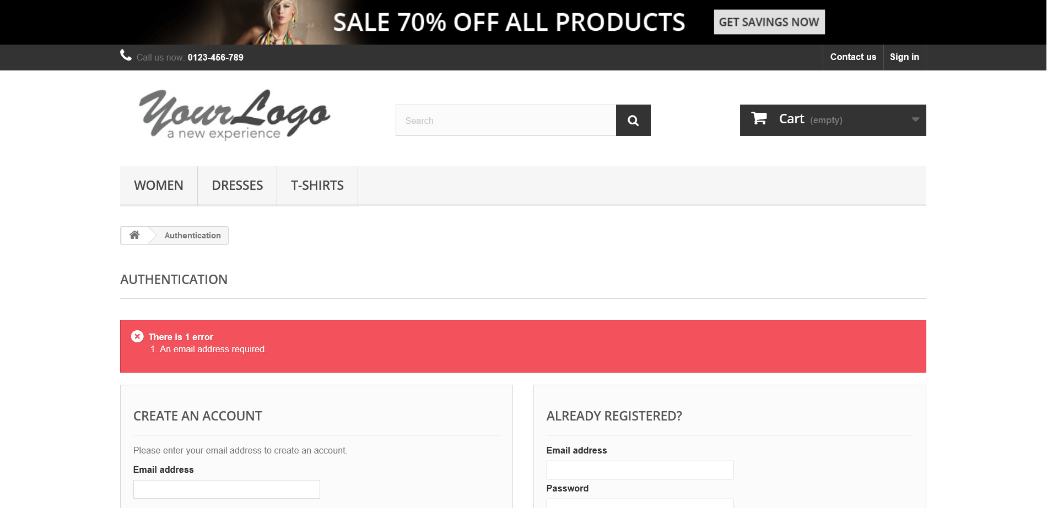

signInRequiredPassword1659013736723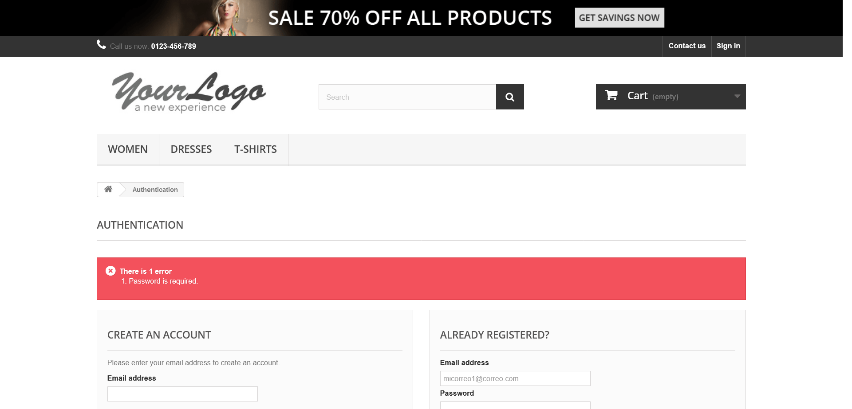

validSignIn1659013743700